1. LED328p (BLV light board) programming test instructions

Preparations (the burned computer does not need, skip to the first step):

1. Add the URL in "File"-"Preferences"-"Additional Development Board Manager URL" of Arduino IDE: https://github.com/adafruit/Adafruit_NeoPixel

2. Add library

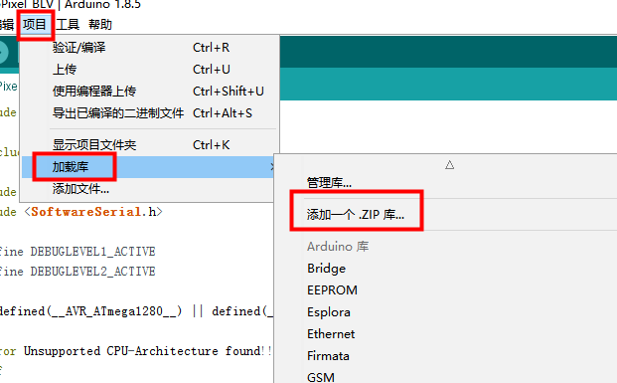



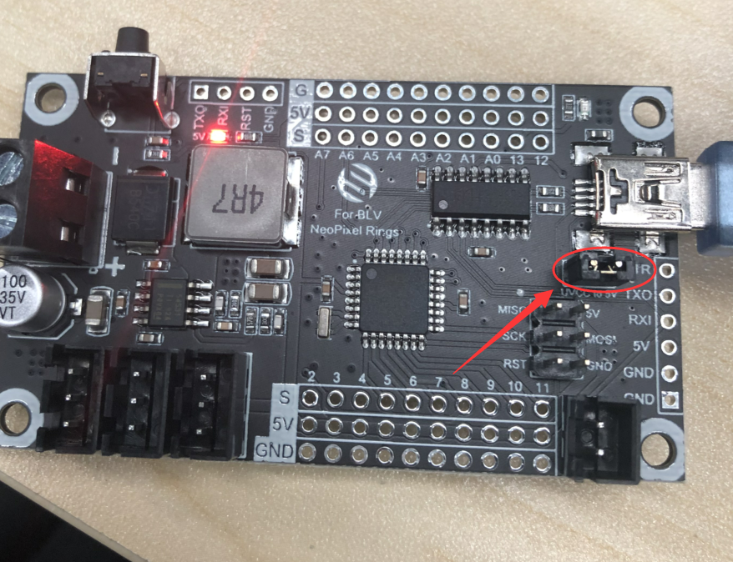

As shown in the figure above, you need to insert a jumper cap to program. Unplug it after burning!

Open project file

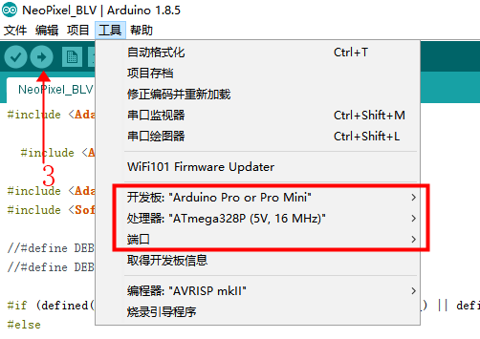

Select "Arduino Pro or Pro Mini" for development board;

The processor selects "Atmega328P (5V, 16MHz)";

Choose the correct port.

Then click to start uploading. When finished, connect the new board and click the upload icon.